# INTRO

There are two categories of streamflow information in our synthetic streamflow framework: direct streamflow sites and indirect streamflow sites. Direct streamflow sites refers to natural flow inputs at five locations at the headwaters of five streams. The second category, indirect streamflow sites, are used to simulate the interactions between our area of focus and water users far downstream of the area without directly modeling the many intervening tributaries and entities. To do this, a ratio approach was developed which necessitated producing downstream natural flow conditions that correspond to one of our direct streamflow input sites. There are two such downstream indirect streamflow sites.

Direct streamflow sites:

1. Upper Colorado River at Granby (UCGranby)- West Slope
2. Fraser River at Granby (Fraser)- West Slope
3. Boulder Creek near Orodell (Orodell)- East Slope
4. Middle Boulder Creek at Nederland (Ned)- East Slope
5. Bear Creek at Morrison (Bear)- East Slope

Indirect streamflow sites:

1. Colorado River below Glenwood Springs (GS)- West Slope
2. Colorado River at Lees Ferry (LF)- West Slope

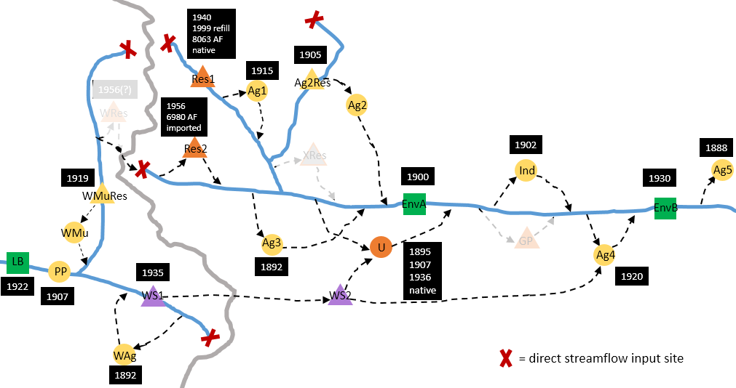

Figure . A diagram of the Hypothetical Front Range Model. Red Xs mark the input locations for the five direct streamflow sites.

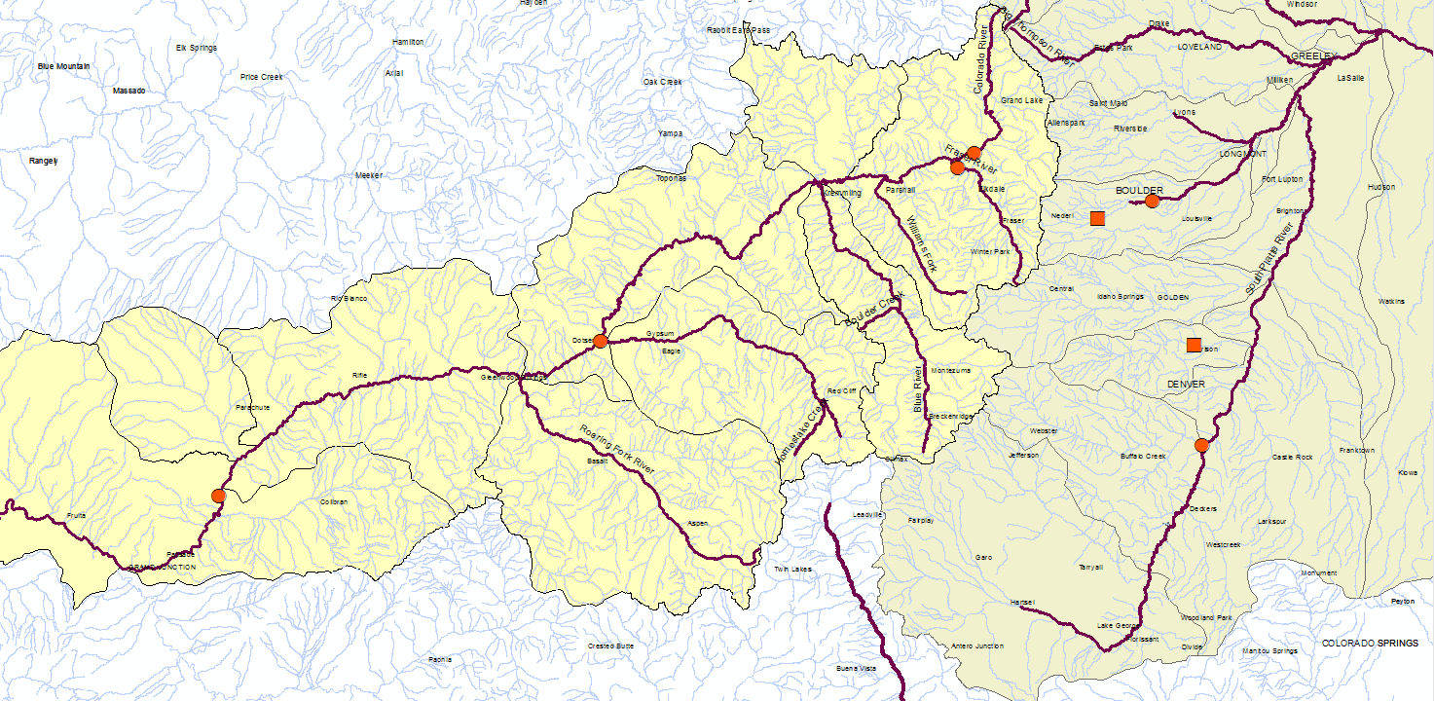

**1**

**2**

**3**

**4**

**5**

**6**

**7**

**8**

Figure . A GIS screenshot depicting the locations of the five gages used for our direct streamflow sites (points 1-5) and three additional sites that were included in the JFRCCVS (points 6-8) which provide climate change deltas for two of our scenarios. Circles denote sites that were included in the JFRCCVS; squares are HCDN sites.

1. Upper Colorado River near Granby (UCGranby)
2. Fraser River near Granby (Fraser)
3. Boulder Creek near Orodell (Orodell)
4. Middle Boulder Creek at Nederland (Ned)
5. Bear Creek at Morrison (Bear)
6. Colorado River near Dotsero (streamflow not used- climate change deltas only; see climate change scenario discussion in Section 4)
7. Colorado River near Cameo (streamflow not used- climate change deltas only; see climate change scenario discussion in Section 4)
8. South Platte River at South Platte (streamflow not used- climate change deltas only; see climate change scenario discussion in Section 4)

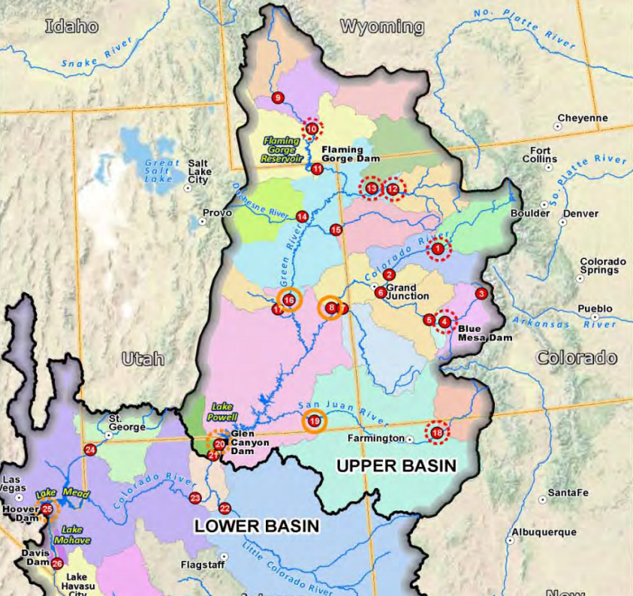

Granby, Colorado

Extent of Figure 1

Colorado River at Lees Ferry (LF)

Colorado River below Glenwood Springs (GS)

Figure . A map of the Upper Colorado River Basin (and a portion of the Lower Basin). The rectangle references the GIS sreenshot in Figure 1 to establish spatial context for the use of the GS and LF gages from USBR, and also conveys the relationships between the two streamflow sites at Granby (points 1 and 2 from Figure 1) and the GS and LF sites.

In order to create sets of stochastic streamflows for this model, three main issues needed to be accounted for:

1. Synthetic flow at direct streamflow sites must exhibit spatial correlation (as regional flow sites naturally would);
2. Indirect streamflow sites must be related to the synthetic UCGranby and Fraser direct streamflows (as downstream sites are naturally dependent on conditions upstream);
3. The process of generating the synthetic streamflows must be compatible with our chosen method of creating alternate hydrologic scenarios- perturbing historic natural flows either regionally or at individual sites and translating the regional effects of those perturbations in a spatially coherent way.

To create these synthetic streamflows, our study uses natural or naturalized streamflows from three sources. Inclusion of multiple streamflow sources was necessary due to the scarcity of gages that have natural flow records of sufficient length. Based on the procedure used in the JFRCCVS (Woodbury et al., 2012), which many of our participants were a part of, a record of 56 water years of monthly natural flow (10/1949 – 9/2005) was the standard for inclusion in our project. The natural flows taken from the JFRCCVS were compiled using several sources, including United States Geological Survey (USGS) gage records, records maintained by water utilities, and data from the State of Colorado. The second source of streamflows was the USGS Hydro-Climatic Data Network (HCDN) network of gages, which are determined to be minimally-affected or unaffected by human interference and which have sufficiently long records (Lins, 2012). Our final source for monthly natural flows is the Bureau of Reclamation’s Colorado River Basin Natural Flow and Salt Data project (Prairie and Callejo, 2005); natural flows are calculated using the observed flows and subtracting out known upstream operations via the Colorado River Simulation System model.

|  |  |  |  |  |  |
| --- | --- | --- | --- | --- | --- |
| **Site Name** | **Site Alias** | **Site Type** | **Data Source** | **USGS Gage #** | **1950 – 2005 Mean Annual Natural Flow (AF)** |
| Upper Colorado River at Granby | UCGranby | Direct | JFRCCVS | 09019500 | 270,989 |
| Fraser River at Granby | Fraser | Direct | JFRCCVS | 09034000 | 151,963 |
| Colorado River below Glenwood Springs | GS | Indirect | USBR | 09085100 | 2,018,046 |
| Colorado River at Lees Ferry | LF | Indirect | USBR | 09380000 | 14,064,826 |
| Boulder Creek near Orodell | Orodell | Direct | JFRCCVS | 06727000 | 71,169 |
| Middle Boulder Creek at Nederland | Ned | Direct | HCDN | 06725500 | 39,970 |
| Bear Creek at Morrison | Bear | Direct | HCDN | 06710500 | 34,753 |

Table . List of reference sites for direct and indirect streamflow inputs, the sources for their records, their USGS gage #s, and their mean annual flows.

Our streamflow generation framework is depicted by Figure 4, and the numbered steps from this schematic are referenced throughout this document.

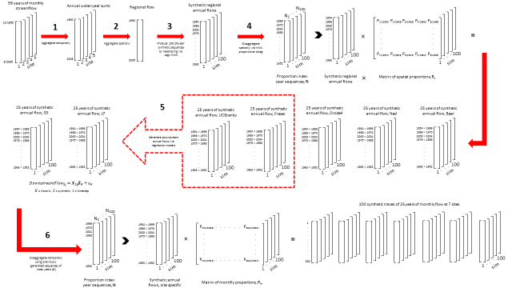

Figure . Framework depicting the process of generating synthetic streamflow timeseries. Step 1 aggregates monthly streamflow data at five direct streamflow sites into water year streamflows; step 2 aggegates annual flows at each site into regional annual flows; step 3 generates synthetic timeseries of regional annual flows; step 4 disaggregates from regional to site-specific annual flows; step 5 uses the synthetic flows from UCGranby and Fraser as inputs into a regression models to predict streamflows at GS and LF; step 6 disaggregates annual flows at all seven sites (five direct and two indirect) to monthly flows for each site.

# HISTORIC SCENARIO

Monthly natural flows for each direct streamflow site are temporally aggregated into water years sums, creating an annual flow sequence (step 1, Figure 4). Next, these sequences of annual flows from each site are summed across the sites to create a sequence of regional annual flows (step 2). A regional annual flow for a given year is the sum of all flow from all sites in that year. This single regional annual flow timeseries is used in a lag1 K-NN bootstrap technique (Lall and Sharma, 1996) to produce a user-specified number of synthetic traces (each of user-specified length) of regional annual flow (step 3). The main parameter of the KNN is the number nearest neighbors, K, which was chosen to be , where *L* is the length of the historic record of annual flows. The weights for sampling from the nearest neighbors is determined by

Equation

with being the closest of the nearest neighbors. The values for both *K* and *W* correspond to the values shown to be effective for a variety of applications by Lall and Sharma.

The rationale of the above approach is that monthly flows were summed to annual for ease of resampling, and to a regional value in order to preserve spatial correlation when generating new flow sequences. The lag1 K-NN resamples the historic record, but results in novel sequences. An initial flow value is chosen at random (*t-1* flow), and flow at time *t* is chosen based on a weighted sampling from among the K neighbors (excluding the *t-1* flow) whose values are closest in magnitude to the *t-1* flow. Each successive regional annual flow value is chosen using this algorithm. The lag1 K-NN method is useful for preserving a variety of statistics including mean, standard deviation, and skew (Lall and Sharma, 1996). The use of only the previous flow value is often appropriate because many flow records show strong autocorrelation at a lag of 1 timestep. The regional annual flow data used here exhibits the largest (though still relatively weak) autocorrelation at a lag of 7 timesteps (see Figure 5), but a comparison of the results of a lag7 and a lag1 K-NN shows that using a lag1 does a better job of capturing the mean and median of the historic regional annual flows (see Figure 6 and Figure 7). Furthermore, since no lags showed very strong correlation, preservation of autocorrelation was not deemed critical.

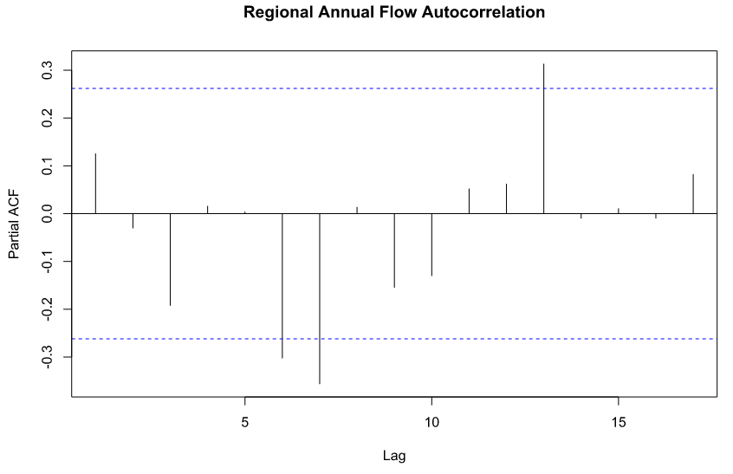

Figure . The partial autocorrelation analysis of the regional annual flow reveals weak autocorrelation at lags of 6, 7, and 13 years.

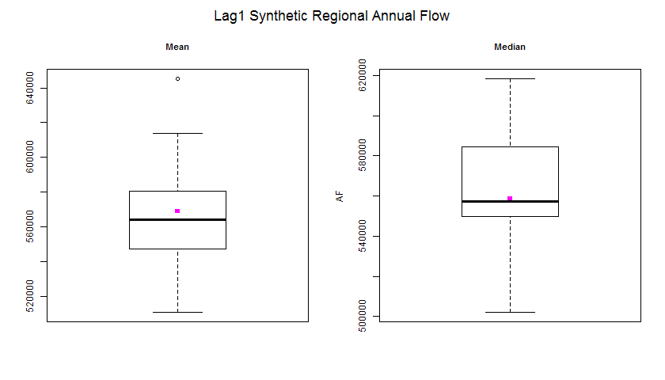

Figure . The 100 sequence of synthetic regional annual flow generated using a lag1 K-NN process perform well at capturing the mean and median (pink dots) of the historic streamflow.

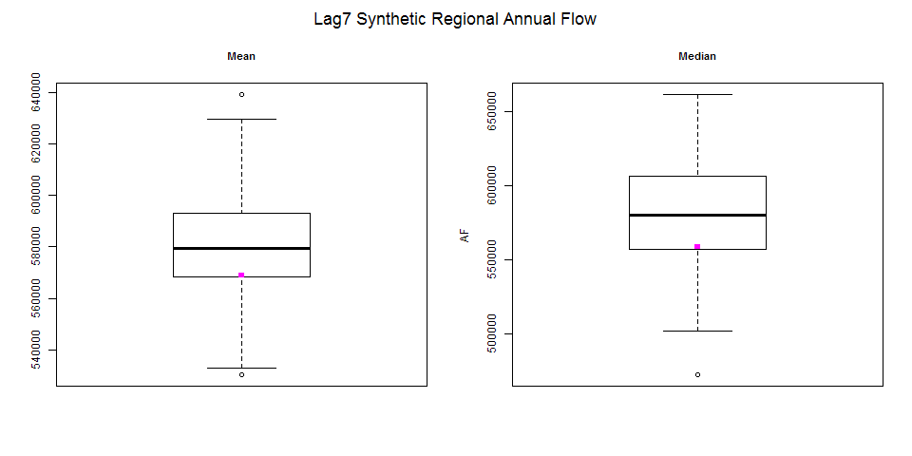

Figure . Despite the strongest autocorrelation occurring at a lag of 7 years, the 100 sequence of synthetic regional annual flow generated using a lag7 K-NN process perform more poorly than the lag1 K-NN at capturing the mean and median (pink dots) of the historic streamflow.

Using the above approach, we created 100 synthetic traces, each 43 years long, of natural regional annual flows. The sequences are 43 years long to facilitate the implementation of LF ratios which depend on a running 10-year sum (see section 5). Ultimately, the middle 25 years (i.e. years 10 – 34) were taken to in order to match the 25-year time horizon chosen for the RiverWare simulation. Using the middle 25 years brings the added benefit of eliminating the influence of the first flow year chosen at random to begin the lag1 K-NN.

The following steps rely on disaggregating the regional annual values back to an annual flow specific to each site (step 4), and then finally to monthly flows at each site (step 6). In order to translate the regional flows back into annual flows at each of our five direct streamflow sites, we used a proportional disaggregation method (Nowak et al., 2010). The method is advantageous because it preserves summability criteria (the component flows sum to the aggregated value), does not depend on data being normally distributed, and can handle disaggregation to sites that have substantially different flow magnitudes (as is the case for our direct streamflow sites). Using the Nowak et al. approach, disaggregation can occur spatially, temporally, or both, by projecting synthetic data onto a vector of historically-observed proportions. The proportions are created by dividing the contributing site (or month, or day) by the total flow value for that year, resulting in percentages that sum to 1. The choice of which historical proportions to use is made via, again, a K-NN approach; it compares each aggregated synthetic flow value to K of the closest values in the historic record, and then assigns an index year based on a weighted sampling of those K values. Below is a numerical example, where ***p*** is the matrix of spatial proportions across five sites for each historical year, ***z*** is the observed regional annual flow, and *Z* is the synthetic regional annual flow corresponding to the regional annual flow from 1967.

Equation

Based on the weighted K-NN resampling, the year 1951 is the chosen nearest neighbor (so *y* = 1951). The 1951 proportion vector, , is multiplied by the synthetic regional annual flow to produce the flow at each site, ***s***.

Equation

Each synthetic flow is assigned an index year, resulting in 100 sequences of 25 index years (so there is a sequence of index years is associated with each of the 100 synthetic traces). These index sequences, denoted by **N** in steps 4 and 6 in Figure 4, will eventually be used to disaggregate annual flows to monthly, but initially, each index year is used to project the regional flow onto the spatial proportions of the five direct streamflow sites exhibited by that index year. The result is 100 sets of 25 years of spatially correlated annual flows for each site consisting of values not seen in the historical record (the flow magnitude from 1951 would not have been included in the set of nearest neighbors from which proportions were chosen). This proportional disaggregation method has been shown to do a good job of preserving mean, median, maximum, minimum, skew, and standard deviation, and as shown in the boxplots below, performs well in our application.

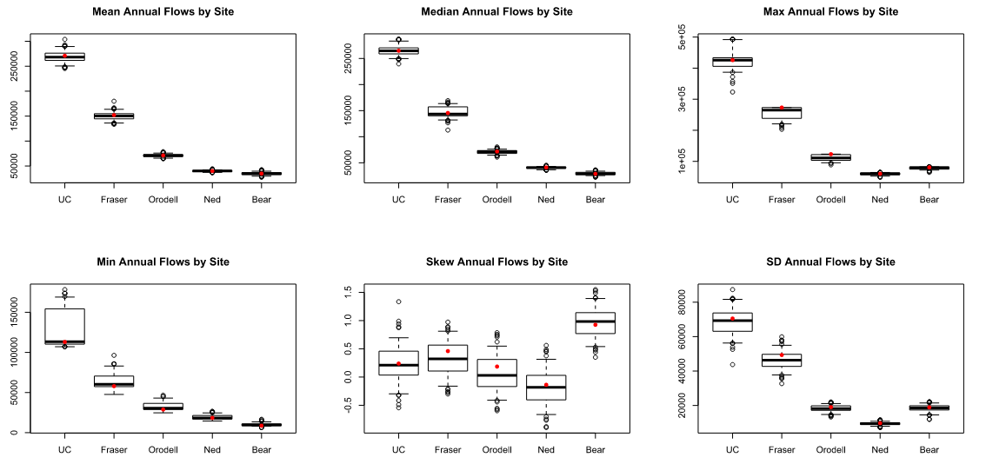

Figure . This series of boxplots shows that the spatial disaggregation of synthetic historic flow sequences from regional annual to site-specific annual flows preserves the historic statistics (represented by red dots) of annual flows at these sites while generating variability.

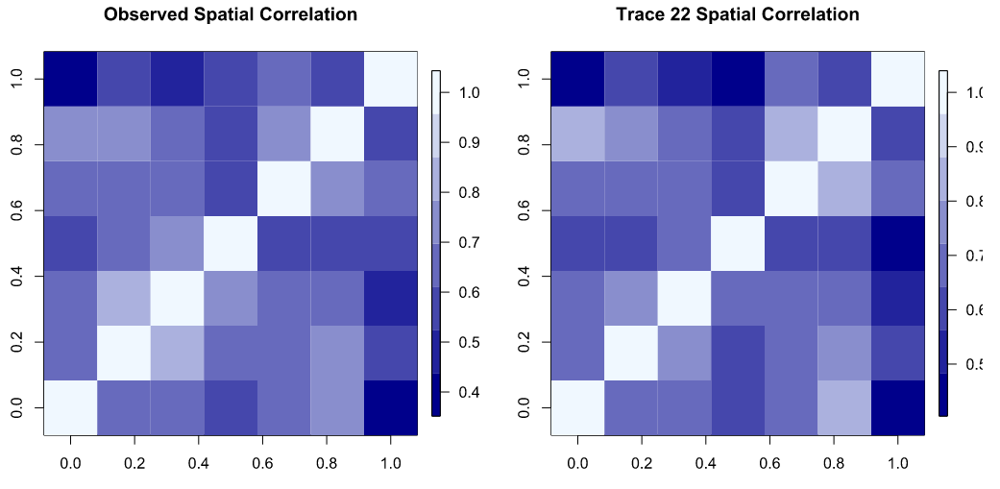

Figure . Observed spatial correlation and spatial correlation for one of 10 traces chosen from the 100 generated. Order of sites on axes (right to left and bottom to top) is: uc, fraser, gs, lf, or, ned, bear; change “observed” to “historic”

Before performing the temporal disaggregation, an intermediate step to generate flows at indirect streamflow sites was necessary (see step 5 in Figure 4). Because they are directly downstream of two of our direct streamflow sites, it was not appropriate to include them in the synthetic regional flow generation; their flow is dependent partly on the upstream sites. We needed correlated flows at the indirect sites in order to determine how much of the flow from our upstream sites should be passed to the downstream points to meet important demands located near the indirect streamflow sites. To simulate flows at GS, a linear regression model was developed to relate historic GS flows to the sum of historic flows at two upstream tributaries (UCGranby and Fraser). After the regression model was created based on this historical record, it was used to generate a synthetic annual GS flow, with the spatially-summed synthetic annual flow from UCGranby and Fraser as the predictor. This resulted in a set of 100 traces of 43 years of annual flow at GS, each value of which is related to the synthetic inputs based on their historic relationship.

The historic model is represented by

Equation

where is the historic flow at time *t* at GS, is the sum of historic flows at time *t* at the explanatory sites (UCGranby and Fraser), is the vector of parameters calculated for the historic relationships via least squares estimate, and is the vector of residuals which are approximately normally distributed. The synthetic response flows, , are then generated via

Equation

Synthetic flows at LF were generated using the same approach, but the model relating the historic flows is a linear regression using the *Gamma* family and the *Identity* link function. Because the annual flow at GS was approximately normal, a simple linear regression performed well. The annual flow at LF was more likely to have resulted from a Gamma distribution, hence the generalized linear regression of family Gamma.

Ultimately, the flows at the indirect streamflow sites are used to develop ratios describing the upstream tributaries’ contributions to the downstream flow. In the case of GS, the ratios will be multiplied by the downstream power plant (*PP*) user’s water rights to assign a flow value that must be passed by our upstream users (Equation 6). The has units of cubic feet per second (cfs). The use of LF ratios is more complex, and is discussed in Section 5. Both ratio applications are used to constrain the amount of water available to the West Slope water users in our model.

Equation

At this stage, having 100 traces of annual flow, each 43 years long, for each of seven sites, we completed the disaggregation process by projecting annual flows onto monthly proportions (Figure 4, step 6). In order to preserve the sub-annual relationships associated with the chosen historic spatial proportions, the sequences of index years produced in the initial disaggregation were applied here. Continuing with the illustrative example in Equation 3, the K-NN sampled regional flow from year 1967, which was disaggregated spatially using the proportions from 1951, will now be disaggregated to monthly flow for each site using the respective site’s monthly proportions from 1951. The result is 100 synthetic traces of 43 years’ worth of novel monthly flows that are spatially correlated at both annual and monthly scales and which form a coherent set of regional streamflows to force our model. We needed 25 years of flow for streamflow inputs in our model (but needed to produced 43 years of flows to properly calculate the LF ratios discussed in Section 5), so we took the flow sequences from years 10 through 34 as our final streamflow sequences. Of the 100 synthetic traces generated, we randomly chose 10.

The ability of this monthly streamflow generation process to replicate statistics and timing of the historic natural flow record is captured in Figure 10 and Figure 11.

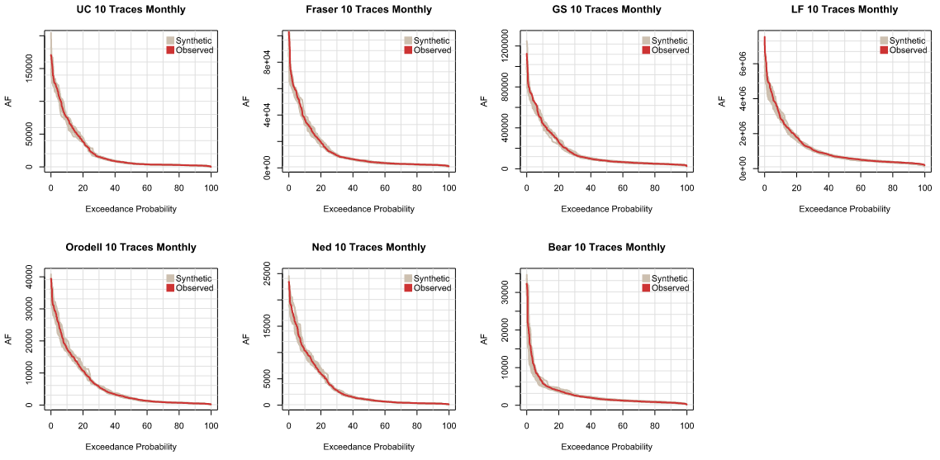

Figure . Flow duration curves of monthly flows at each site for the 10 randomly chosen traces.

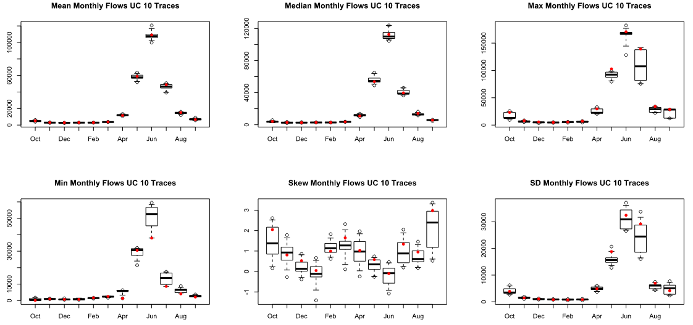

Figure . Boxplots of monthly flows at UCGranby across the 10 randomly chosen traces for each month and each of six statistics. The distribution of synthetic traces does a good job of capturing the historic statistics which are represented by red points.

# “HISTORIC PLUS” SCENARIO

Above, we describe the application of our streamflow generation process to 56 years of historic monthly natural flows in order to create a set of synthetic flows that exhibit the mean and variability of the historic record. Our participants are also interested in hydrologic futures that deviate from the observed, and we used the same framework to generate 100 streamflow traces for each of three additional scenarios. Specifically, we created two different climate change scenarios and a scenario that could be described as “historic plus”- that is, the timing of flows throughout the year does not change (as would be likely under a warming climate, e.g. Lukas et al., 2014), and the magnitudes of extremes are essentially the same, but there is a higher probability of drought years than historically observed. To create the “historic plus” scenario, we borrowed a piece of the method recently proposed by Herman et al (In Review) to generate synthetic droughts.

Kirsch et al (2013) note that previously proposed synthetic streamflow generation methods have exhibited either inability or weakness in replicating both historic interannual autocorrelation and the seasonal shifts in autocorrelation. To address this, they propose a modified fractional Gaussian noise (mFGN) approach that reorganizes matrices of simulated flows such that the second half of sub annual flows for a year is paired with the first half of sub annual flows from a succeeding year and using Cholesky decomposition to impose autocorrelation on uncorrelated flows. Spatial correlation across multiple sites is maintained through the fact that a single bootstrap resampling matrix of indices is applied to the flows at all locations. Herman et al (In Review) expanded on this method by building in a way to flexibly perturb the historic record via adjustments to a drought threshold, *p*, and increase in frequency, *n* (e.g. a user chooses to create a scenario where the lowest 20% of streamflows are twice as probable- *p = 0.2, n = 2*). It is this approach to flexible perturbation that we make use of.

Qsynth, the expansion introduced by Herman et al (In Review), was developed to facilitate exploration of bottom-up vulnerability analyses- where observed events that caused severe system stress are artificially imposed at greater frequency while approximately maintaining other streamflow statistics. One reason this approach is valuable is that it uses high-consequence events from managers’ recent memories to frame a hydrologic future that may be experienced as a result of a changing climate (i.e. more frequent extremes). In their original proposals, both Kirsch and Herman suggested the best use of the method was for weekly, or at least sub annual, data, but because streamflow in Colorado is highly concentrated in the runoff months (May-July), increasing the probability of sampling a week or month within the lowest 25% of flows is not meaningful. Additionally, in order to preserve autocorrelation, the prevalence of additional low flow months would cause high flow months to be spuriously high in magnitude.

The Qsynth method is not appropriate for our purposes for four reasons:

1. Increased sampling of low-flow months creates unrealistic flow patterns and volumes, thus an annual timescale must be adopted;
2. It is common for water managers in this area to think of streamflow at an annual timescale because the vast majority of flow occurs as a result of melting snow, the volume of which is related to each year’s winter season;
3. The most appropriate spatial scale for us to generate a “historic plus” scenario is at a regional scale because our utility, consistent with real utilities on the Front Range, depends on water from multiple watersheds; and
4. It would not benefit us to generate synthetic spatial disaggregation proportions, so simulating each of our five direct inflow sites individually is unnecessary.

Since we do not need to preserve spatial correlation at this step of the generation process and we cannot divide each year’s simulation into two parts to impose autocorrelation, there is no need to use Qsynth. However, the approach to flexibly increase the probability of droughts in a way that our participating water managers can easily relate to is a useful concept, so we will employ the drought threshold and frequency parameters, *p* and *n.* Below is a demonstration of their use with our 56-year historic record.

Let us say that managers are most concerned about the possibility of the lowest 10% of annual flows becoming twice as common, so the drought threshold *p* = 0.1 and the frequency *n* = 2, and as the length of the historic record, *h* = 56. The lowest flows from the record are selected, and a random sampling with replacement of of the flows are appended to the historic record. In our example, that means the six lowest flow were sampled (with replacement) six times and those six sampled flows were appended to give 62 regional annual flows. From this augmented set of flows, any number can be resampled in any of several ways (randomly, via lag1 K-NN, etc.) but we used random sampling (with replacement) to create a hypothetical 56-year flow series. From 100 simulated series, we chose one at random and fed it into step 3 of our of our streamflow generation process (see Figure 4). The characteristics of this trace are shown by Figures 12 - 15.

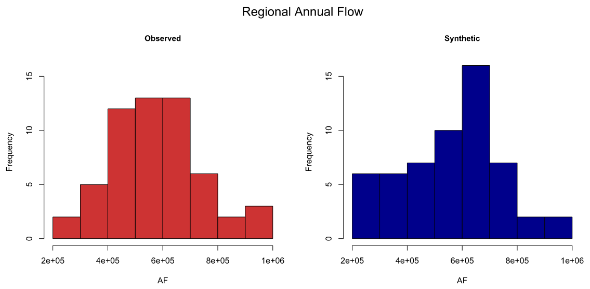

Figure . (a) Histogram of the observed regional annual flow compared to (b) histogram of the randomly chosen “historic plus” trace. Note that the range of flows is the same, but the center of mass of the “historic plus” sequence is shifted to the left.

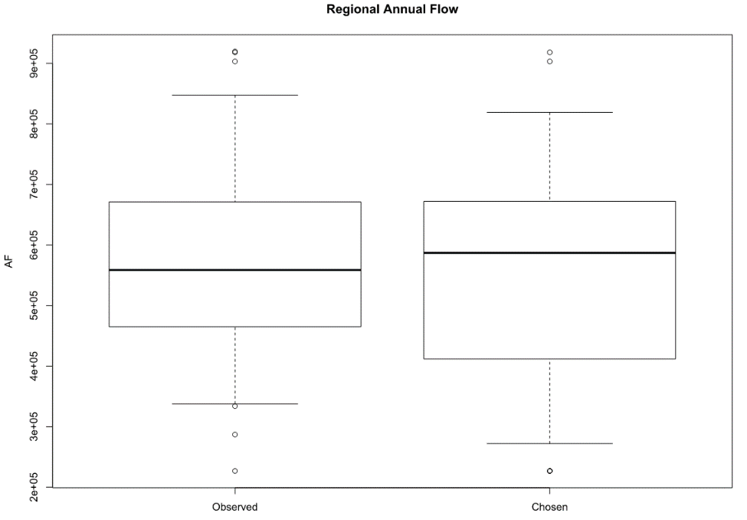

Figure . Boxplots comparing the historic streamflow and the chosen “historic plus” streamflow sequence.

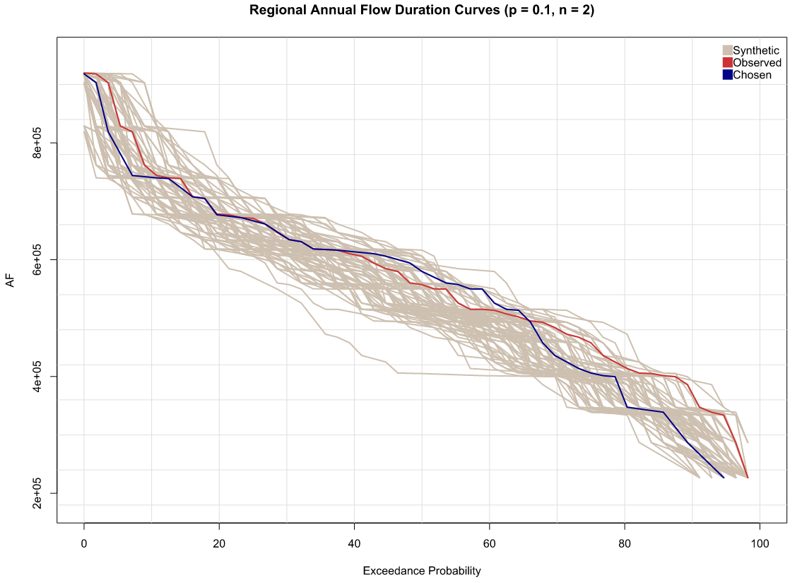

Figure . Flow duration curves for all of the synthetic regional annual “historic plus” traces generated plotted with the historic and the chosen trace.

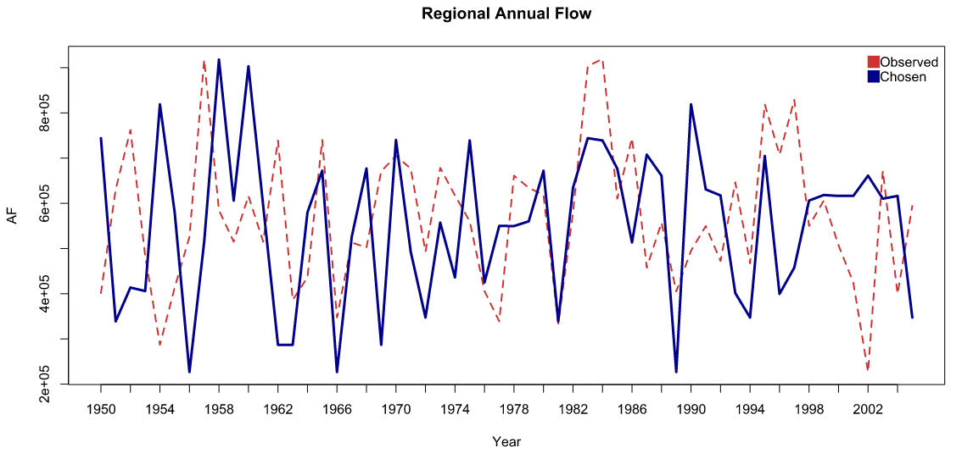

Figure . 56-year timeseries comparing the historic regional annual flow sequence to the randomly chosen “historic plus” sequence. Note that the historic 2002 drought was sampled three times in the synthetic sequence.

By combining this perturbed series with a lag1 K-NN resampling and historic spatial and temporal disaggregations, we maintain the spatial and monthly patterns of the observed hydrology, consistent with the idea of a scenario that behaves similarly to historic hydrology but with more frequent droughts. Considering the common mentality (and the reality) on the Front Range that 2002 was the driest year anyone had ever seen, and it came as the third dry year in a row, the concept of sampling flow sequences from a distribution in which the driest 10% of years are twice as likely to occur is easily understood by regional water managers as increasing the possibility of experiencing multiple periods resembling 2000-2002. The result is not a severe reduction in the longterm flow outlook, or a change in timing of flows, just an increase in dry years (or drought frequency). Figures 16 - 19 compare historic to “historic plus” for the regional annual, site-specific annual, and site-specific monthly flows resulting from the streamflow generation process.

# 3.2 “HISTORIC PLUS” RESULTS

Below are four figures that convey the magnitude shifts at both annual and monthly scales and the absence of an annual hydrograph timing shift (consistent with the goal of this scenario- higher frequency of droughts but no change in snowmelt runoff timing). The boxplots of mean, median, max, min, skew, and standard deviation of monthly flows at six additional sites can be found in Appendix B.

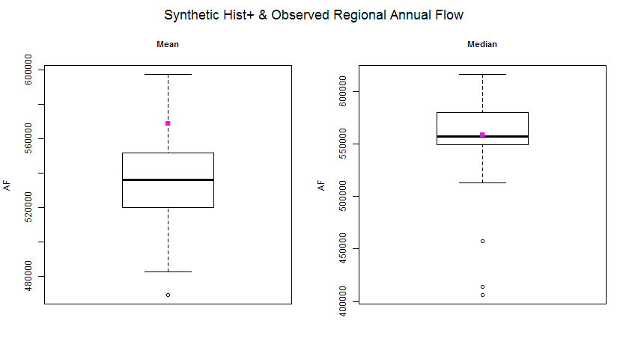

Figure . Boxplots of the mean and median regional annual flow of the 100 synthetic “historic plus” sequences plotted against the historic mean and median in pink.

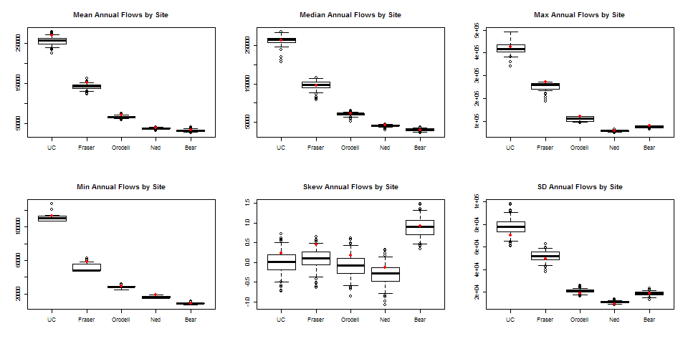

Figure . Site-specific boxplots of annual flow showing that the “historic plus” annual flows at each site maintain the general patterns exhibited by the historic (red dots) but are generally shifted slightly lower due to the higher presence of droughts.

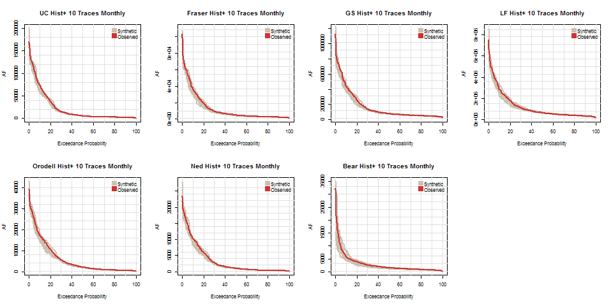

Figure . Flow duration curves for the 10 randomly-chosen “historic plus” traces of monthly flow at all seven sites. Note that the distribution of curves around the historic is a mix of higher and lower flows at most exceedance probabilities (but slightly favoring lower flow magnitudes).

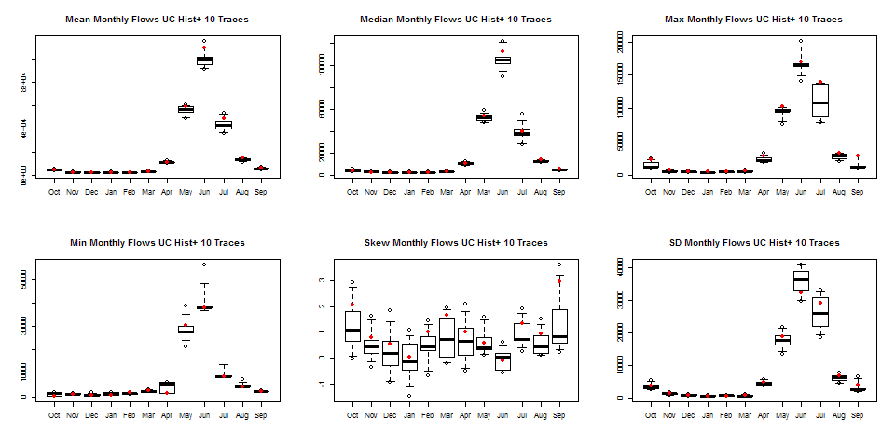

Figure . Boxplots of monthly flow at UCGranby comparing the distribution of monthly flow statistics from the 10 “historic plus” traces to those of the historic monthly flow (red dots). The temporal patterns of monthly statistics are maintained while the magnitudes are decreased.

# 4.1 CLIMATE CHANGE SCENARIOS

To create stochastic streamflows representative of two climate change scenarios, we draw on the results of the 2012 Joint Front Range Climate Change Vulnerability Study (JFRCCVS) (Woodbury et al., 2012). In that study, Front Range water managers interacted with researchers to develop a method for generating practical climate change-affected streamflows for various regional sites. They used downscaled and bias-corrected temperature and precipitation outputs from CMIP3 as inputs to two calibrated hydrologic models- a SAC-SMA model and a WEAP model. The outputs of the study were a set of monthly streamflow deltas for each site; that is, at each site and for each month, they calculated the average change in streamflow between a climate change scenario and the historic hydrology (as computed by the hydrologic model). Though deltas for 12 scenarios were produced using each model, based on input from several water managers, we chose to use two sets of deltas; one resulting from a forcing of 1C warming and one from 4C warming. Because the impacts of climate change on precipitation for the region are highly uncertain (including the possibility that there will be no change at all) (Lukas et al., 2014), water managers are inclined to focus more on the implications of warming.

As stated, each site included in the JFRCCVS has a set of monthly deltas associated with it. For the streamflow sites we incorporated that were not used in the study, we used the deltas from the geographically nearest JFRCCVS sites and applied them directly or calculated hybrid deltas, as documented in this list:

1. UCGranby: deltas directly from JFRCCVS
2. Fraser: deltas directly from JFRCCVS
3. GS: deltas calculated from a simple average of the JFRCCVS deltas for Colorado River near Dotsero (USGS gage # 09070500) and Colorado River near Cameo (USGS gage # 09095500); GS is approximately halfway between these two sites
4. LF: deltas from Colorado River near Cameo; Cameo is the furthest downstream site in the JFRCCVS and though this is far upstream of LF (with many intervening tributaries), there are no analogous deltas for LF and the alterations in streamflow timing were most important since the only way the climate change-altered flows are used in our process is to generate the monthly proportions (the same is true of the climate change-altered flows for GS).
5. Orodell: deltas directly from JFRCCVS
6. Ned: Orodell deltas (the two sites are very close to one another- see Figure 2)
7. Bear: a weighted average of the Orodell deltas and JFRCCVS deltas from the South Platte River at South Platte site were used; 1/3 weighting for Orodell, 2/3 weighting for South Platte. The Bear gage is roughly 50% closer to the South Platte site (see Figure 2)

Once we had a set of deltas for each of our sites, we multiplied the historic monthly natural streamflows by their respective sets of deltas. Since there is only one delta for each month (not a series of 56 years’ worth of monthly deltas), the October flow in each year was altered by the same percentage- the October delta- and the November flow in each year was altered by the November delta, etc. These altered monthly flows were then fed into the streamflow generation framework: they were summed to water year flows, aggregated to regional annual flows, resampled, disaggregated spatially using climate change- altered spatial proportions, GS and LF flows were generated (using the regression model created from historic flows), and finally all sites were temporally disaggregated using climate change-altered monthly proportions that corresponded to the proportions used in the spatial disaggregation. Figures 20 - 24 compare historic to the 1C warming scenario for the regional annual, site-specific annual, and site-specific monthly flows resulting from the streamflow generation process. Figures 25 – 29 in Section 4.3 are the same comparisons for the 4C warming scenario.

# 4.2 CLIMATE CHANGE RESULTS (1C)

Below are five figures that convey the distribution shift, the magnitude shifts at both annual and monthly scales, and the slight annual hydrograph timing shift resulting from a relatively moderate temperature increase. The boxplots of mean, median, max, min, skew, and standard deviation of monthly flows at six additional sites can be found in Appendix C.

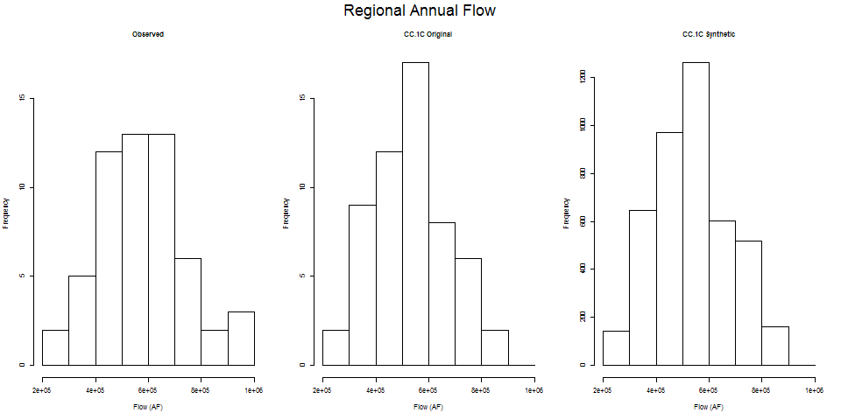

Figure . (a) histogram of historic regional annual flow as compared to the (b) original flow sequence altered by climate change deltas and (c) the distribution of 100 synthetic climate change sequences.

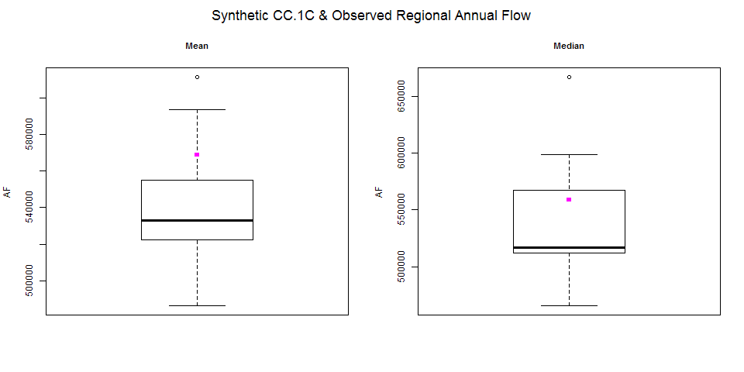

Figure . Boxplots of the mean and median regional annual flow of the 100 synthetic climate change sequences plotted against the historic mean and median in pink.

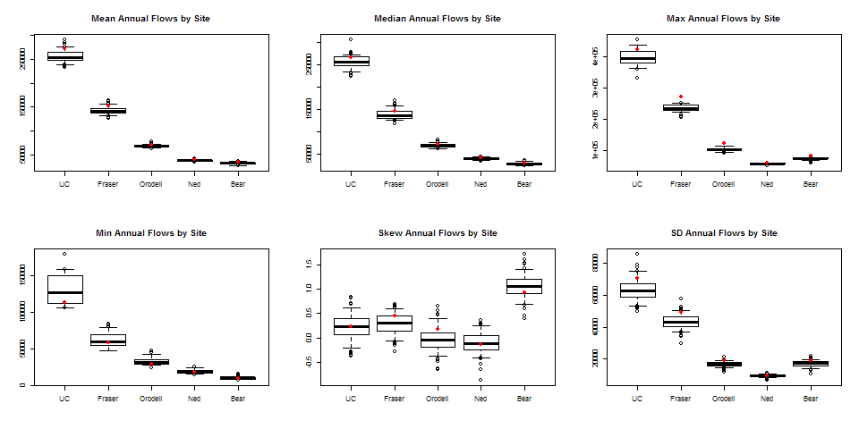

Figure . Site-specific boxplots of annual flow showing that the climate change-altered annual flows at each site maintain the general patterns exhibited by the historic (red dots) but are generally shifted slightly lower due to reduced streamflow in a warmer climate.

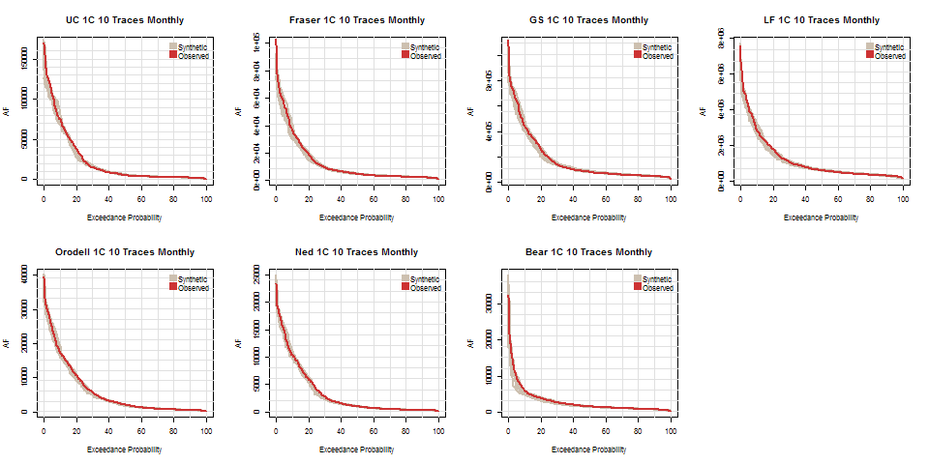

Figure . Flow duration curves for the 10 randomly-chosen climate change traces of monthly flow at all seven sites. Note that the distribution of curves around the historic falls generally below historic at most exceedance probabilities.

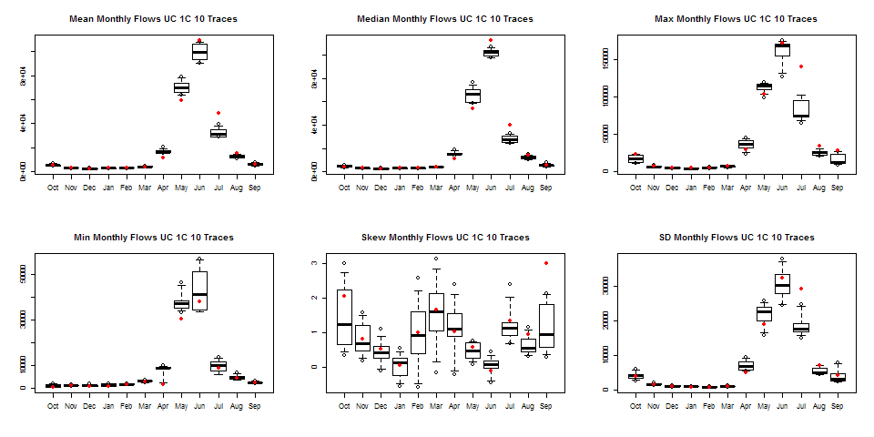

Figure . Boxplots of monthly flow at UCGranby comparing the distribution of monthly flow statistics from the 10 climate change-altered traces to those of the historic monthly flow (red dots). The temporal patterns of mean, median, max and min statistics for the climate change traces show the beginnings of a shift in the annual hydrograph which will occur as the speed and timing of snowmelt changes.

# 4.3 CLIMATE CHANGE RESULTS (4C)

Below are five figures that convey the distribution shift, the magnitude shifts at both annual and monthly scales, and the prominent annual hydrograph timing shift resulting from a large temperature increase. The boxplots of mean, median, max, min, skew, and standard deviation of monthly flows at six additional sites can be found in Appendix D.

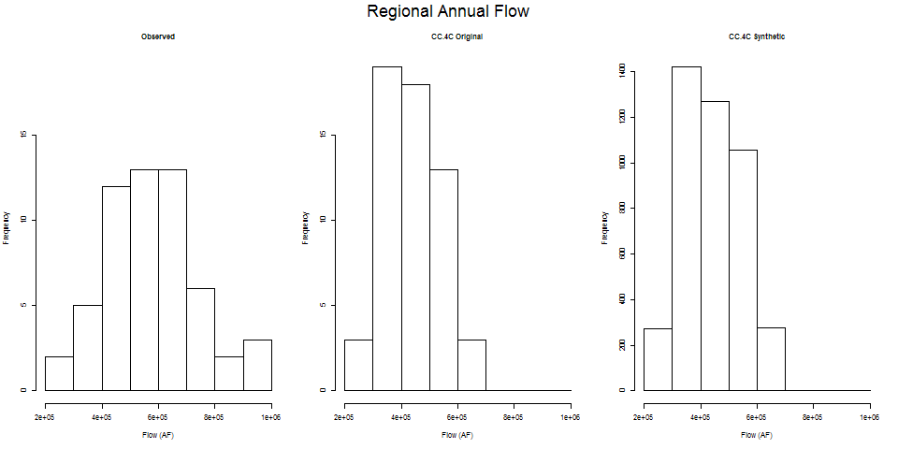

Figure . (a) Histogram of historic regional annual flow as compared to the (b) original flow sequence altered by climate change deltas and (c) the distribution of 100 synthetic climate change sequences.

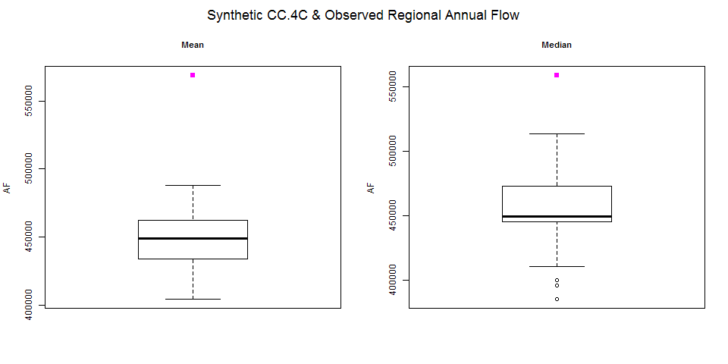

Figure . Boxplots of the mean and median regional annual flow of the 100 synthetic climate change sequences plotted against the historic mean and median in pink.

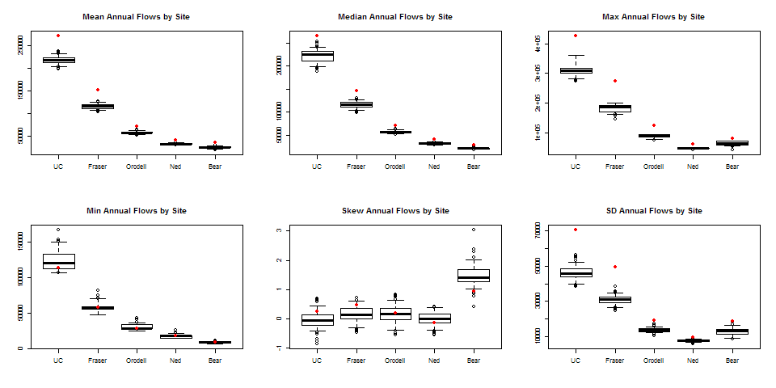

Figure . Site-specific boxplots of annual flow showing that the climate change-altered annual flows at each site maintain the general patterns exhibited by the historic (red dots) but are generally shifted much lower due to reduced streamflow in a much warmer climate.

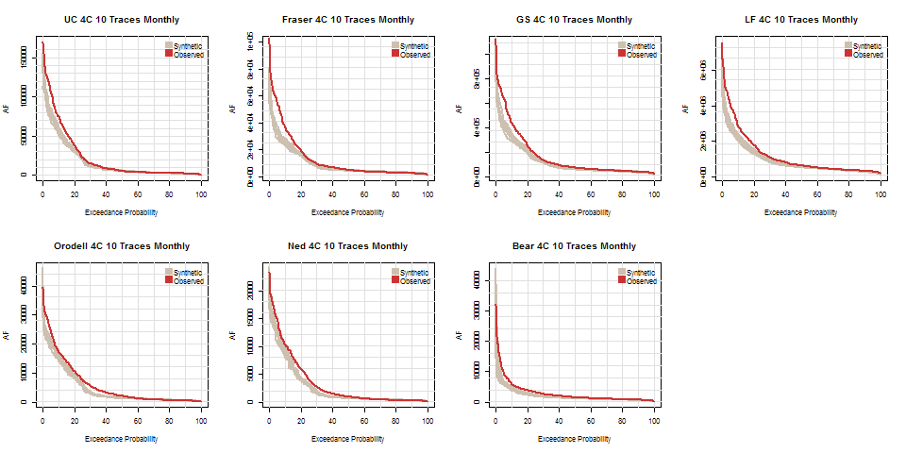

Figure . Flow duration curves for the 10 randomly-chosen climate change traces of monthly flow at all seven sites. Note that the distribution of curves around the historic falls well below historic at most exceedance probabilities.

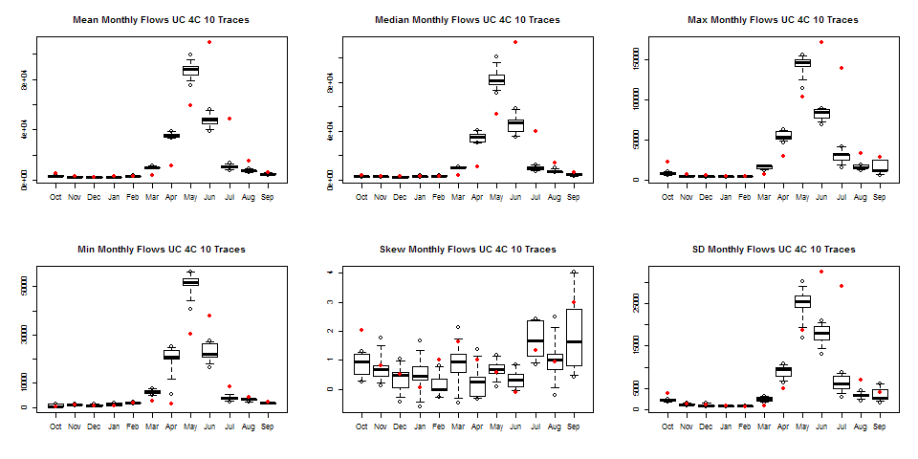

Figure . Boxplots of monthly flow at UCGranby comparing the distribution of monthly flow statistics from the 10 climate change-altered traces to those of the historic monthly flow (red dots). The temporal patterns of the mean, median, max, min, and standard deviation statistics for the climate change traces show the dramatic shift in timing of peak runoff from June in the historic record to May.

# LF RATIOS

In order to determine how much streamflow the water users on the West Slope of our model must pass every month to satisfy the Upper Colorado River Basin’s required delivery to the Lower Basin, we had to develop a method of evaluating the monthly flow in the headwaters of our West Slope (comprised of UCGranby and Fraser) in the context of a 10-year running sum at a far downstream site (see Figure 3). Based on the Colorado River Compact of 1922 and subsequent acts, treaties, and agreements (collectively called “The Law of the River”, <http://www.usbr.gov/lc/region/g1000/lawofrvr.html>), the Upper Basin must deliver 82.3 million acre-feet (MAF) over the course of any 10 years to fulfill the rights of the Lower Basin states and Mexico. The geographic location the delivery must reach is called Lees Ferry, (LF).

For initial explanation purposes, let us say that the way the 10-year running sum requirement is met by delivering 8.23 MAF per year. Because subannual flow is seasonal, we could not just divide 8.23 MAF by 12 months and claim that this volume of water should reach LF. This meant we needed to know how much water each contributed to the required annual flow, or = 8.23 MAF.

First, we got the monthly proportions at LF for each water year such that .

e.g. if the annual flow for the 1950 water year (October 1949 – September 1950), was 13.3 MAF and October 1949 flow, = .54 MAF,

If = 8.23 MAF, then .

Then we needed to know how much of the 0.33 MAF must be met by the headwaters of our West Slope tributaries (*tribs*). To determine this, we calculated the ratio of our *tribs* to the monthly flow at LF

Using this ratio, we calculated how much our *tribs* must contribute to :

In reality, it would be unreasonable to crudely impose an when interannual flow at LF is so variable; the Law of the River calls for the 10-year running sum at LF to be 82.3 MAF, and in practice, wet years contribute more to that sum than do dry years. To adhere more closely to reality, we needed to decide how much of the 82.3 MAF each year out of 10 should contribute.

We can do this using annual-to-decadal proportions (which exactly correspond to the concept of monthly-to-annual proportions described above).

e.g. if = 0.093, 1950 contributes 9.3% to the 10-year sum.

However, because it’s a 10-year running sum, each year is a member of 10 decadal sums:

1950 is included in

Because, in general, a dry year would be a dry year no matter which 10-year period we selected and a wet year would be a wet year, the annual-to-decadal proportion for any given year should be relatively stable across its 10 groups. We found this to be generally true, as shown in Table 2.

Table . Ranges of the 10 annual-to-decadal proportions for historic LF flow 10/1970 – 9/1995.

|  |  |  |  |  |  |  |  |  |  |  |  |  |  |
| --- | --- | --- | --- | --- | --- | --- | --- | --- | --- | --- | --- | --- | --- |
|  | **1971** | **1972** | **1973** | **1974** | **1975** | **1976** | **1977** | **1978** | **1979** | **1980** | **1981** | **1982** | **1983** |
| **min** | 0.1034 | 0.0862 | 0.1341 | 0.0895 | 0.1061 | 0.0697 | 0.0315 | 0.0813 | 0.0962 | 0.0946 | 0.0471 | 0.0913 | 0.1296 |
| **max** | 0.1135 | 0.0946 | 0.1421 | 0.0956 | 0.1222 | 0.0826 | 0.0400 | 0.1092 | 0.1292 | 0.1271 | 0.0633 | 0.1188 | 0.1635 |
|  |  |  |  |  |  |  |  |  |  |  |  |  |  |
|  | **1984** | **1985** | **1986** | **1987** | **1988** | **1989** | **1990** | **1991** | **1992** | **1993** | **1994** | **1995** |  |
| **min** | 0.1322 | 0.1150 | 0.1221 | 0.0905 | 0.0647 | 0.0554 | 0.0536 | 0.0738 | 0.0686 | 0.1195 | 0.0698 | 0.1310 |  |
| **max** | 0.1549 | 0.1474 | 0.1579 | 0.1243 | 0.0873 | 0.0714 | 0.0672 | 0.0925 | 0.0831 | 0.1402 | 0.0794 | 0.1492 |  |

Thus, it was reasonable to take the average of a year’s proportions across its 10 groups and call that value its decadal proportion.

Our model uses streamflow traces that are each 25 years long. Within that span, only 7 years have all 10 of their decadal groups included (years 10 – 16). We wanted to capture the full context of each of our 25 years; that is, we needed to know what each of our simulation years contributed in all of the 10 decadal sets in which they figured. Although not included in our model simulation, year 1 of our simulation did technically have years that preceded it, and year 25 had years following. In order to capture all 10 sets for all 25 years, we must add 9 years to the beginning of the set (so that our first simulation year is the 10th in the sequence) and add 9 years to the end (so that our 25th simulation year is the 1st in a set of 10). Our historical record could accommodate this since it is 56 years-long and our synthetic simulations can all be generated at any desired length. Thus, we generated synthetic sequences that are each 43 years-long and used years 10 – 34 out of the set as streamflow inputs to the model.

By using a 43-year sequence each resulting annual-to-decadal proportion was the average contribution of that year to the 10 decadal sums of which it was a component. Now that each of our 25 years had its average proportion, we multiplied the set of proportions by 82.3 MAF to calculate the . This value replaces the value.

Let’s say the average annual-to-decadal proportion of 1950 is 0.096:

Then we recalculate

The October ratio of our *tribs* to LF is unchanged, and we use it to calculate the decadally-adjusted volume of water that must be passed

After completing this process for the 25-year historic span of 10/1970 – 9/1995, the mean of the 25 values of = 8.221912 MAF.

For the 16 sets of 10-year spans within that 25 years, the mean of the 10-year sums was 8.308445 MAF.

A plot of the running 10-year sum with horizontal line at 82.3 MAF:

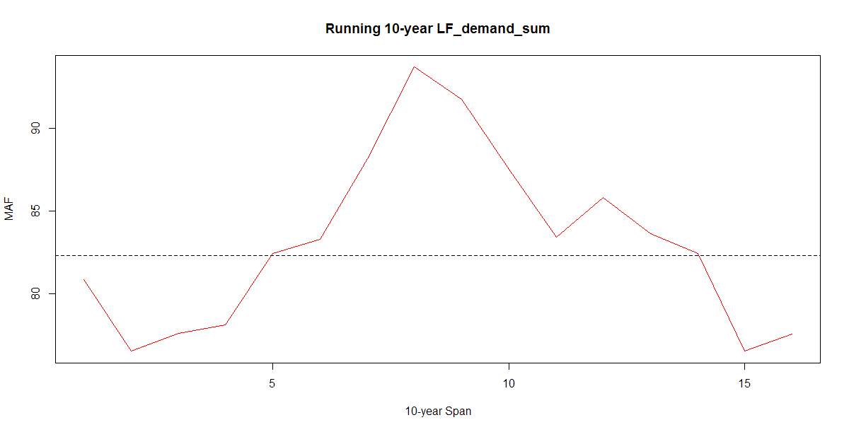

Though delivery to LF is an accurate geographic description, Lake Powell, a very large reservoir, sits just above LF and, among other functions, helps to smooth out delivery variability. Just below LF is Lake Mead, the largest reservoir for the Lower Basin. Each year, the beginning estimated release from Lake Powell is 8.23 MAF, but this can change depending on supply to the reservoir and balancing considerations between Lakes Powell and Mead (<http://www.usbr.gov/uc/water/crsp/cs/gcd.html>). For example, in March 2016, based on the forecasted spring runoff, releases from Lake Powell are projected to be 9 MAF. The timing of releases is impacted by many factors, including unexpected power shortages that require Powell to operate in such a way that there are no service interruptions. There is a large amount of storage in Lake Powell to attenuate fluctuations in Upper Basin annual flows (24.3 MAF total), and the minimum recorded storage since the reservoir filled was 7956023 AF in April of 2005 (<http://lakepowell.water-data.com/index2.php?annualextr=1980>). Considering these facts, it is reasonable to accept the fluctuation in running 10-year sums exhibited in the above graph, where the largest shortfall is 5.8 MAF and the largest exceedance is 11.4 MAF.

In summary, we used the 25 year sequences of averaged decadal contribution, the annual flow at LF, the proportions of monthly to annual flow at LF, and the ratio between the sum of UCGranby and Fraser flow to LF monthly flow to create a method to calculate a realistic monthly Lower Basin demand for any hydrologic scenarios.

# Appendix A: Additional Historic Scenario Results

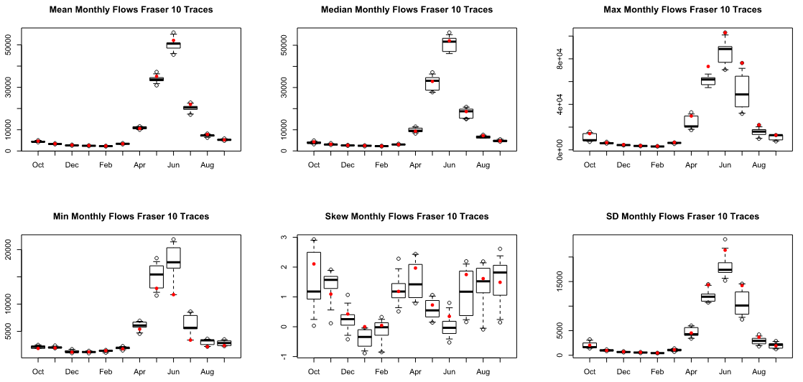

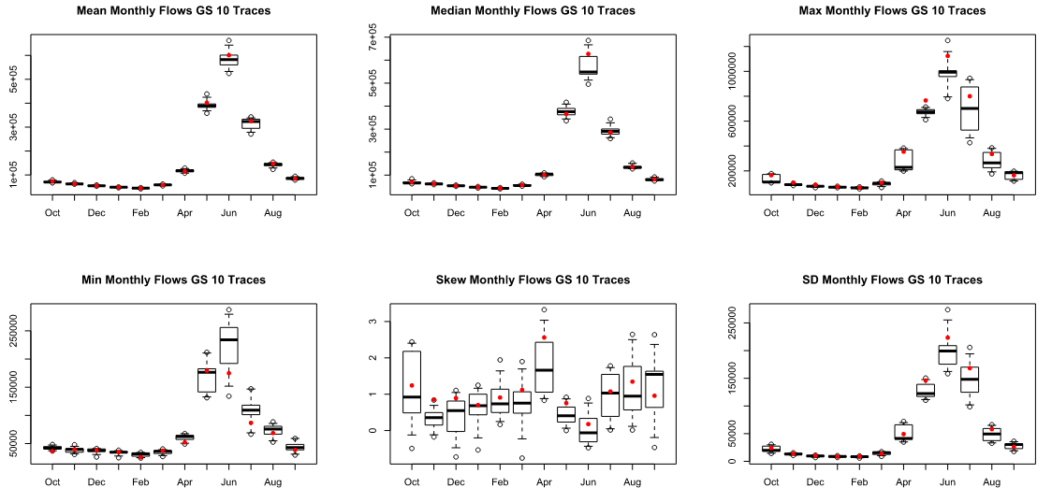

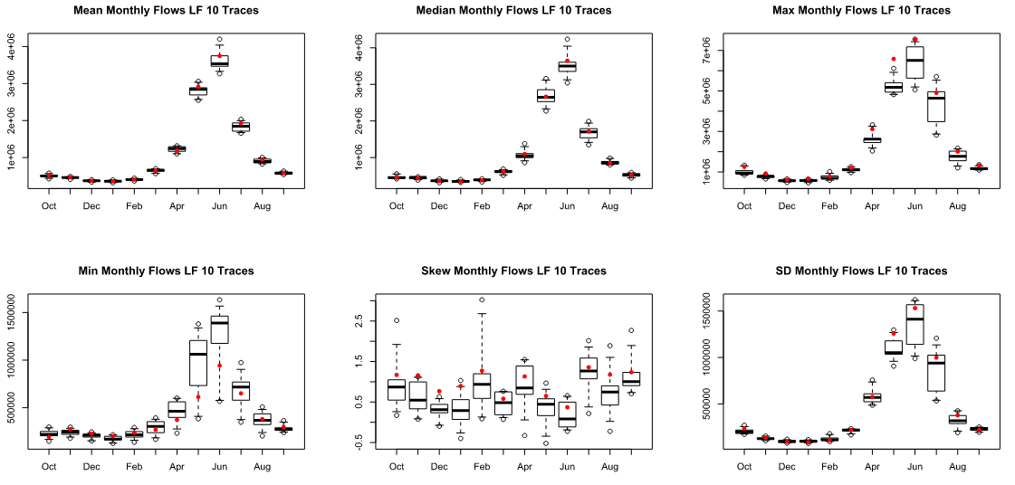

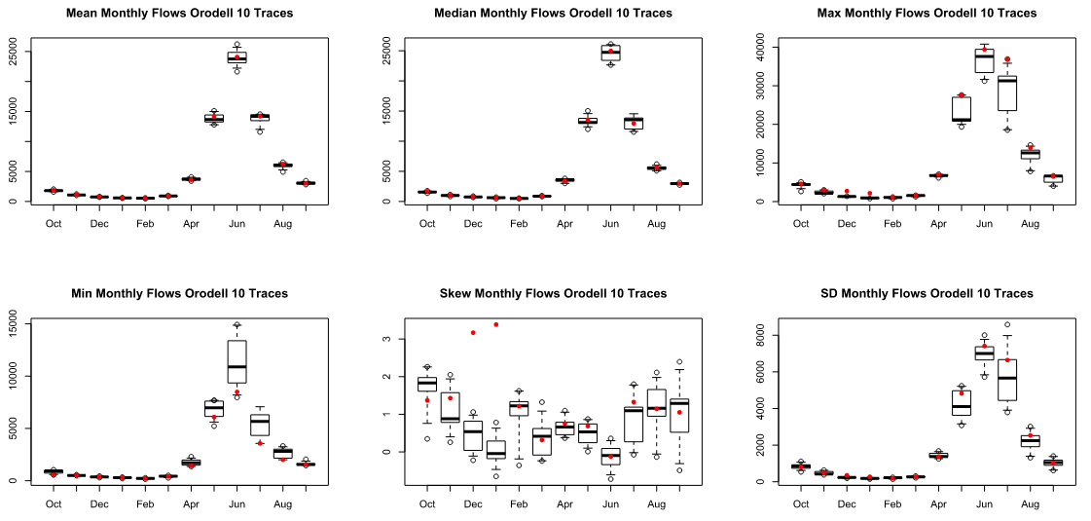

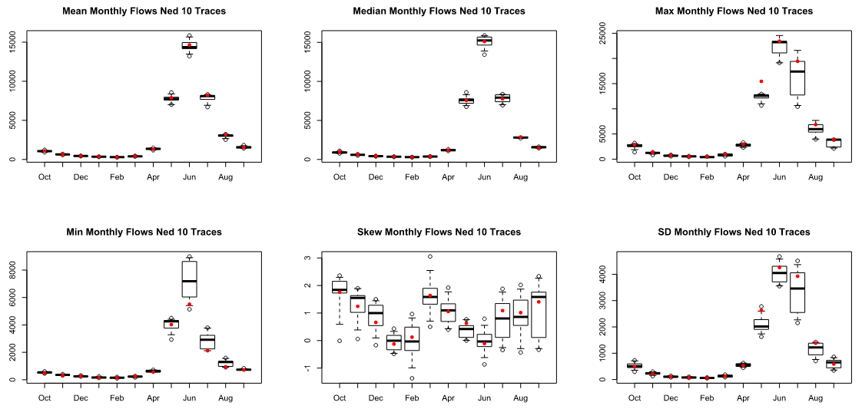

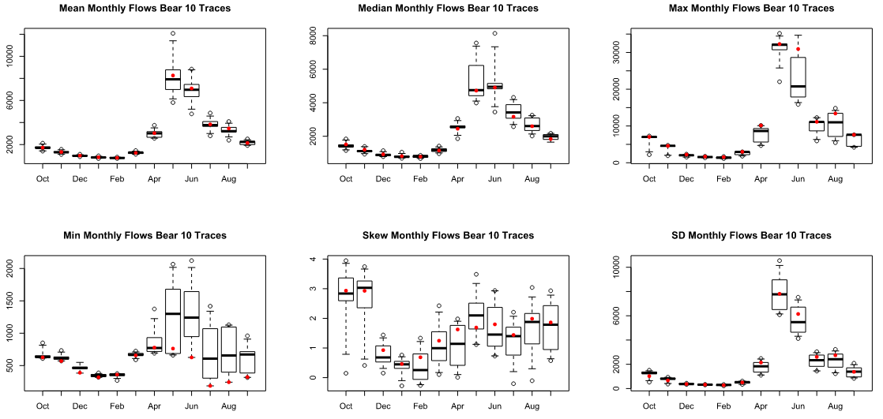

# Appendix B: Additional “Historic Plus” Results

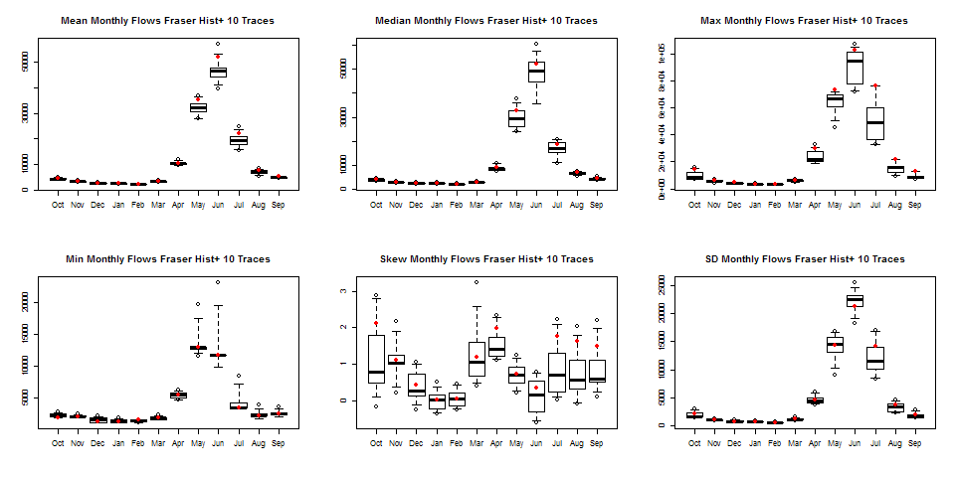

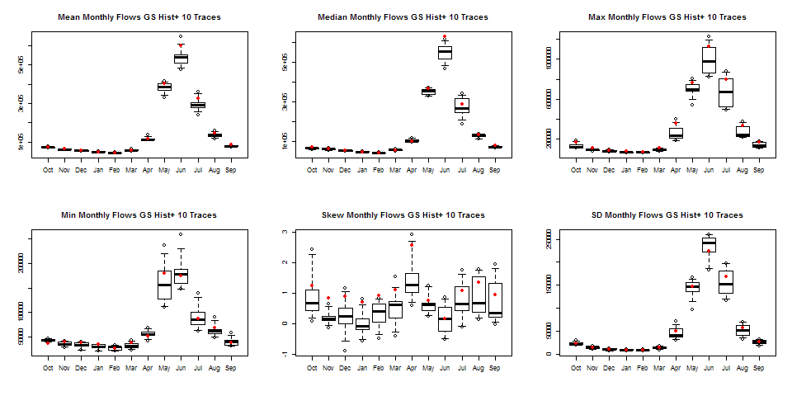

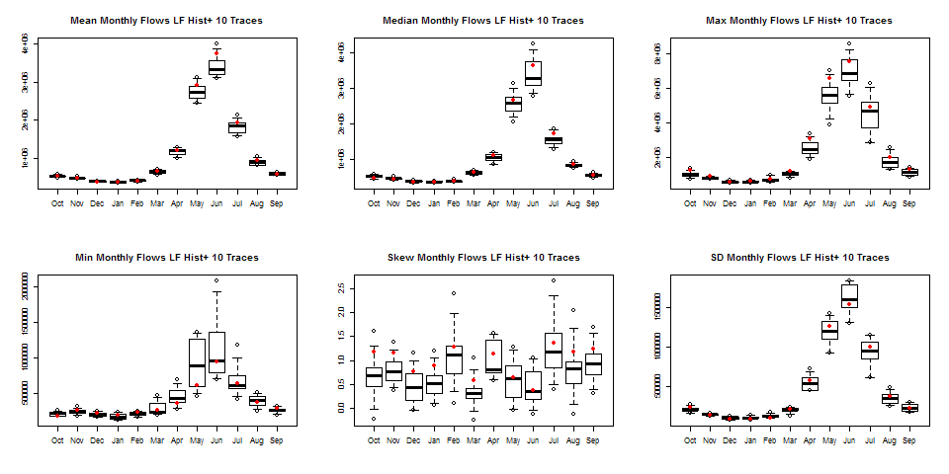

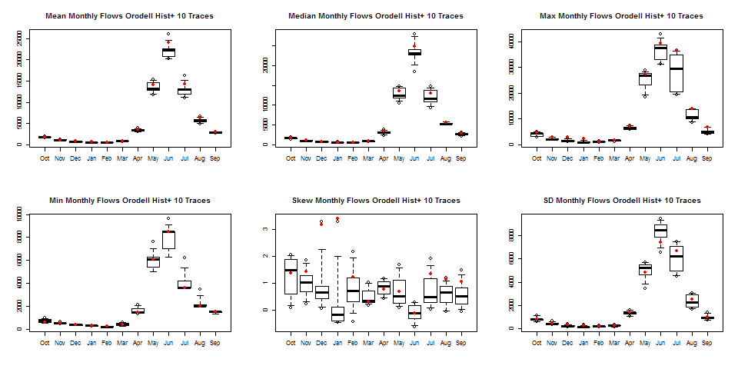

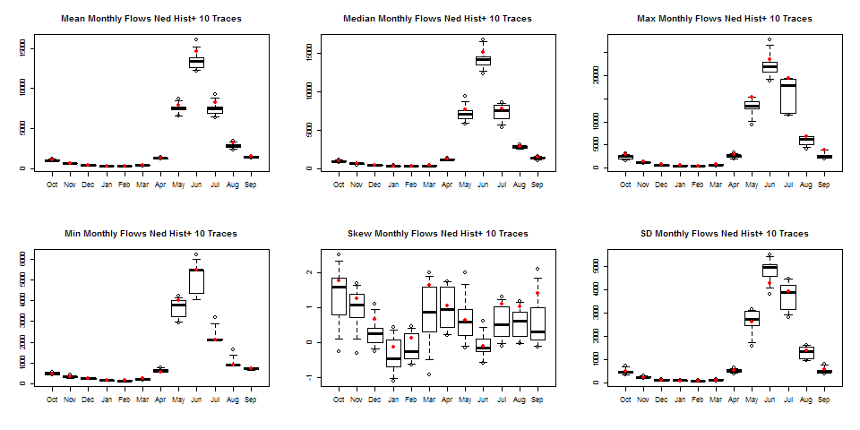

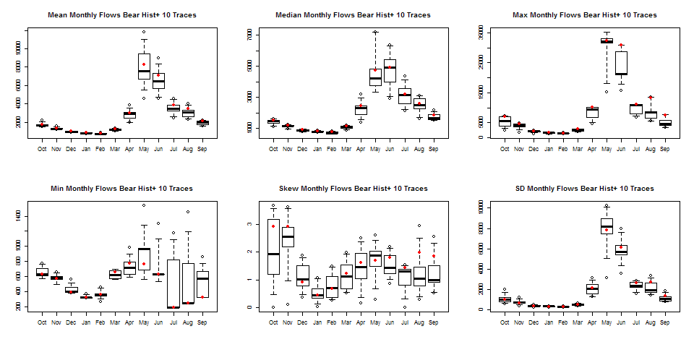

# Appendix C: Additional Climate Change (1 C)

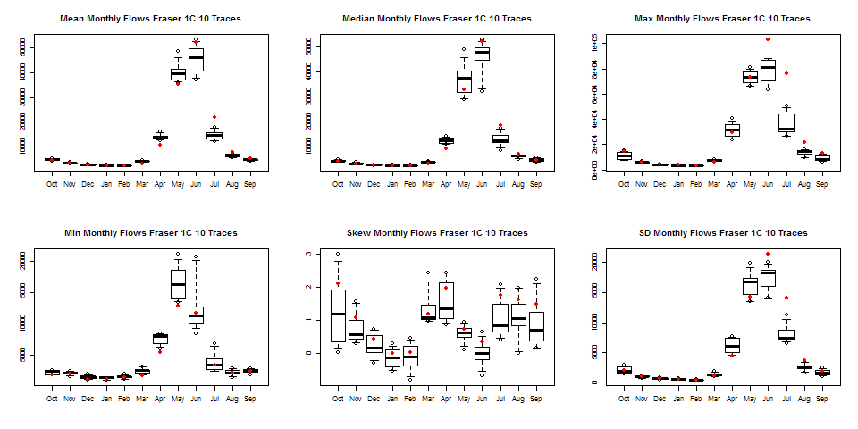

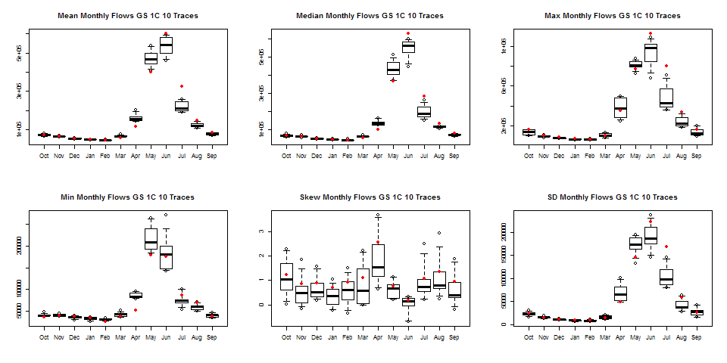

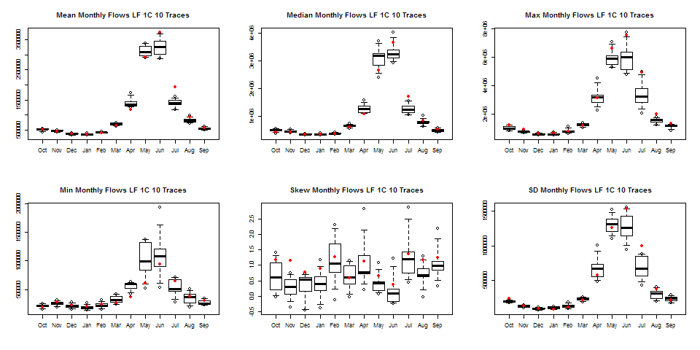

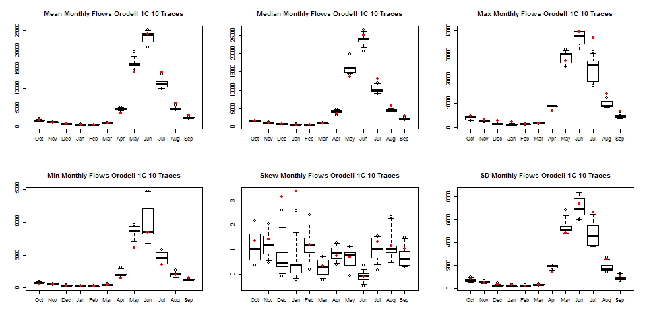

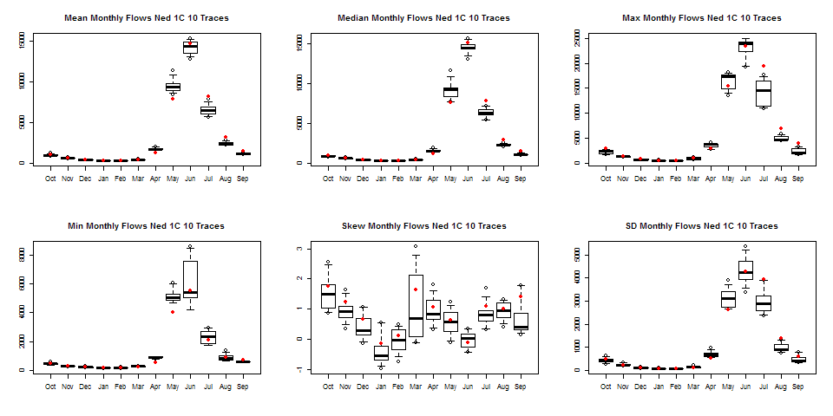

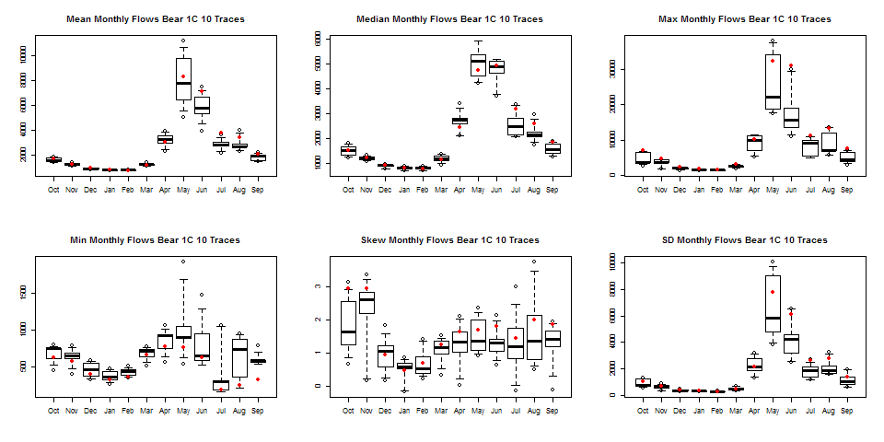

# Appendix D: Additional Climate Change (4 C) Results

